FAQs
Q: Will I need to provide new documents?
A: All applicants will be asked to provide up to date documentation such as
- ID
- Proof of address
- National insurance details
- Supporting evidence of your housing circumstances (Medical reports, Police statements etc.)

Q: What forms of ID are acceptable?
A: Photographic ID is required.

Q: Why do I need to provide ID?
A: All applicants are required to provide proof of their identity to reduce the opportunity for fraud.

Q: What happens if I don’t provide ID?
A: Should ID not be provided within the requested timeframe your application will be closed

Q: Why is the proof of my child benefit not acceptable?
A: We need to make sure that the information shows the names of your children, your name, your address, the amounts you are being paid. Please use this link to be able to provide the correct information: Prove you qualify for Child Benefit - GOV.UK (www.gov.uk)

Q: Can I have a paper application form?
A: There are no paper application forms available, however applications can be completed over the phone or at a drop in session for applicants who do not have access to the internet

Q: If I don’t know my reference number what can I do?
A: This is the reference that you used to login in to Homesearch. If you are unsure what it is please contact one of our Housing Needs Assistants on 0115 917 3347

Q: I have tried to apply but I don’t have an email address?
A: You can contact one of our Housing Needs Assistants on: 0115 917 3347 where an officer will support you to complete an application but please note your application will automatically go onto auto bid.

Q: How do I know if I have been accepted onto the Housing Register?
A: You will receive an email confirming that you have been accepted onto the Housing Register. This will tell you the Band you have been placed in and the date your application has been registered from. you may be asked to supply further information, and you should do this as soon as possible as this may affect your priority on the waiting list.

Q: What if I am waiting for my old application to be made active?
A: Any applications that were not active by 28th May will not be processed on the old Choice Based Lettings System (Homesearch) Applicants will need to reapply on the new Choice Based Lettings System (Homechoice)

Q: Why is my application not active?
A: If you have provided all the supporting evidence, we do have lots of applications that we are working on to make active, and we are treating these ones as our priority. However, if you have not been able to supply all the supporting evidence that we require, we will not be able to make your application active.

Q: Why is my application a different band to the one I had on Homesearch?
A: The reason for this could be that we have been able to make your application active, with the evidence that you have provided, but we still require up to date supporting evidence, to ensure that your band is correct.

Q: Can I be refused from the Housing Register?
A: There are some people who are not eligible, or do not qualify to be included on the Housing Register, these are;
- Certain people who are subject to Immigration Control under the 1996 Asylum and Immigration Act
- Certain people from abroad who are not subject to immigration control but who are not habitually resident in the UK, the Channel Islands, the Isle of Man or the Republic of Ireland.
For further information on immigration control please go to: www.gov.uk/home-office
- If you do not meet the local connection criteria outlined in the Allocations Policy
- Because they have been guilty of unacceptable behavior that makes them unsuitable to be a tenant
Even if people are eligible, they may not qualify to access the Homechoice scheme

Q: How will my application be assessed?
A: Your housing application will be assessed in accordance with the Housing Allocations Policy of the Council you have applied to and will be placed into a band in accordance with your housing need.

Q: Do I need to renew my application each year?
A: Yes, once a year, normally on the anniversary of your application you will be invited to complete your renewal. You will either be sent an email where an email address has been provided, or via the post. The easiest way to renew your application is to complete the renewal online. If you fail to complete your renewal within 14 days your application will be closed.
Support and Assistance
Q: What do I do if my circumstances change?
A: It is very important that you tell us of any changes in your circumstances so that we can amend your application. We will tell you if this results in your application moving to a different band. If your priority is increased, then the date used will be the date you are awarded a higher band. If your priority decreases the date used will be your original date of application.
If you move address you must notify us and we will close the existing application, this is because your housing need is partly assessed on the type of accommodation you live in already. You will be able to make a new application online with your current circumstances.
Q: I have just recently completed my renewal online, will I have to do it again?
A: Unfortunately, we are unable to transfer existing applications to the new system, so you will need to do this again.

Q: What if I do not have access to the internet?
A: there are a number of ways to do this, can contact one of our Housing Needs Assistants on; 0115 917 3347 where an officer will support you to complete an application but please note your application will automatically go onto auto bid. You can contact Citizens Advice at either their Eastwood hub or at their hub at the Council Offices; 0800 1448848. If you are a current council tenant and live in an Independent Living Scheme, your Independent Living Coordinator will be able to assist.

Bidding

Q: How many properties can I bid for?
A: You can bid for up to 3 properties in each advertising cycle.

Q: If I bid for a property earlier in the advertising cycle am I more likely to get it?
A: No - bidding earlier in the advertising cycle will make no difference. Properties are allocated in accordance with the Housing Allocations Policy to the person on the shortlist in the highest band and who has been registered for the longest time.

Q: How do I bid for properties?
A: Existing Homesearch users will need to register with Homechoice on this link: www.broxtowe-homechoice.org.uk/create
New applicants will be able to bid for properties once their application has been assessed and made active

Q: When can I start to bid on properties in Homechoice?
A: You can only bid once your application has been made active. The weekly bidding cycle is Thursday to Tuesday.

Q: Why am I not able to place bids?
A: There are a few reasons, why this is possibly the case:
- You may not be eligible for properties that are being advertised
- Your application may not be active.
What can customers expect to see?
The customer can expect to see the below screen on our website:
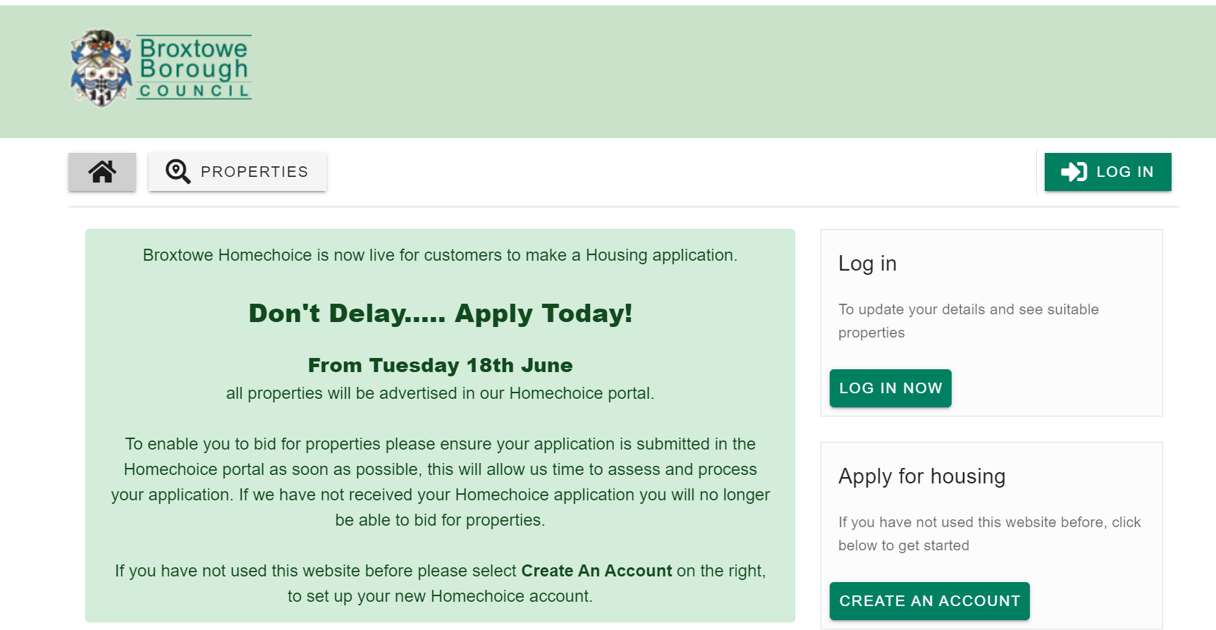
Customers will be asked to create an account
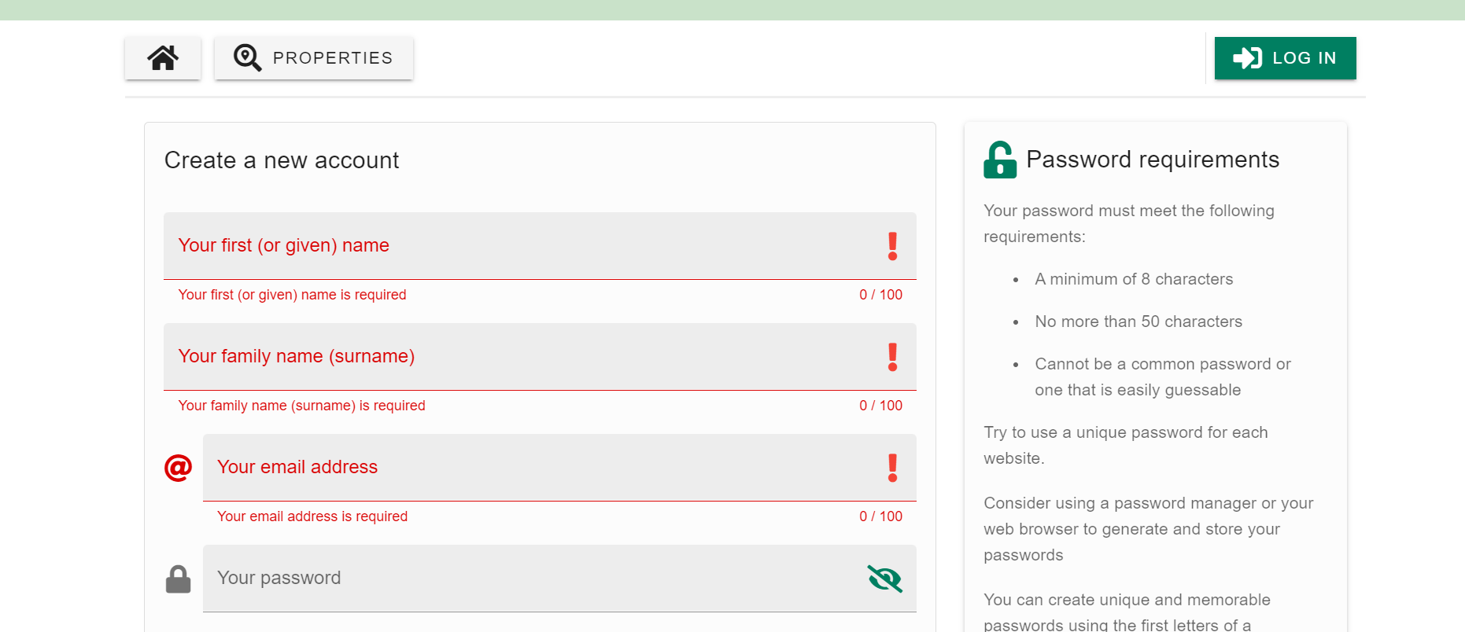
Once customers have created their account they can create the profile by following the on screen instructions
