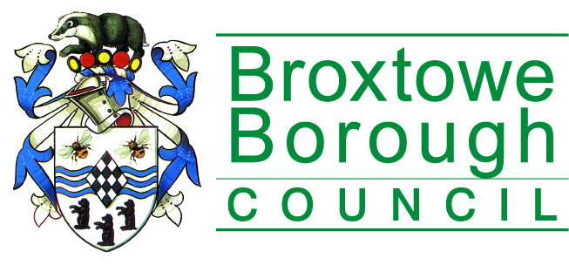 | Broxtowe Borough Council  Licensing Section  Public Protection Division  Council Offices, Foster Avenue,  Beeston, Nottingham, NG9 1AB  Phone: 0115 917 3241  Fax: 0115 917 3683  Email: licensing@broxtowe.gov.uk

Consent of individual to being specified as Premises Supervisor

I ………………………………………………………………….
Full name of prospective premises supervisor

of ………………………………………………………………………………………………..
home address of prospective premises supervisor

Hereby confirm that I give my consent to be specified as the designated premises supervisor in relation to the application for

………………… ……………………………… type of application

by ……………………………………………… name of applicant

relating to premises licence ………………… number of existing licence, if any

for ……………………………………………………………………………………………….
name and address of premises to which the application relates

and any premises licence to be granted or varied in respect of this application made by ……………………………………………… name of applicant

concerning the supply of alcohol at

…………………………………………………………………………………………………..
Name and address of premises to which application relates

I also confirm that I am entitled to work in the United Kingdom and am applying for, intend to apply for or currently hold a personal licence, details of which I set out below.

Personal Licence Number ……………………………………………………
Insert personal licence number, if any

Personal licence issuing authority ……………………………………………
Insert name, address and telephone no of authority

Signed: …………………………………………………

Name: ………………………………………………….
Please print name

Date: ……………………………………………………

